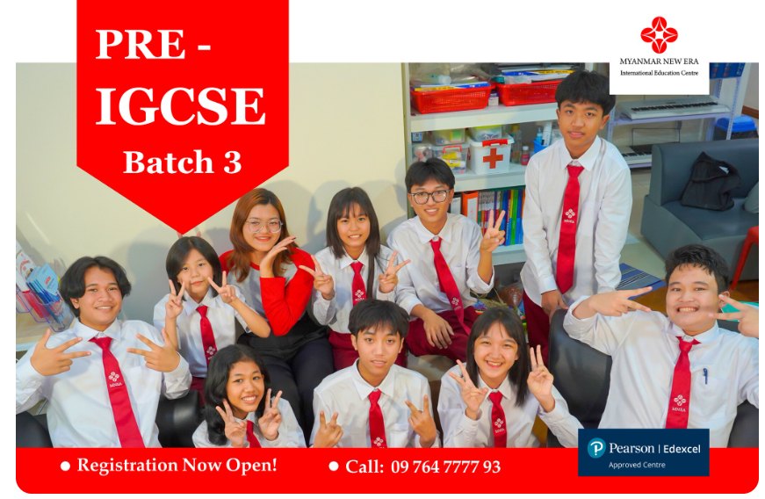 | Global Primary Learning Program  Global Primary Learning Program is designed to build a strong academic foundation for young learners through core primary subjects, practical classroom learning, and supportive skill development.  Take free placement test
Program Overview: This programme helps children strengthen key subjects such as English, Mathematics, Science, and Computing while also developing creativity, social understanding, and everyday life skills through carefully chosen extra subjects.
Who Should Join: Young learners who need a strong primary-level foundation in English and academic subjects, together with supportive enrichment subjects that help them grow with confidence.

Subjects:  Core Subjects  - English (EFL)  - Mathematics  - Science  - Computing | Extra Subjects  - Myanmar  - Art & Music  - PSHE (Personal, Social, Health and Economic Education)
Program Details
Duration :9 MonthsJune 2026 - February 2027
Starting Date :1 June 2026
Days :Sunday to Friday
Time :1:00 pm - 6:00 pm(As per after-school timetable)

Take free placement test

